A. Find Area

Maryam is a high school student and she like to solve math. One day at a class she draw two circle and try to calculate critical area. The critical area is area of two circle without common area. After that she becomes bored to find the critical area. Now you help her to find out the critical area.

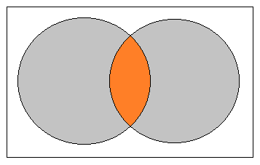

INPUT

First line contains number of test case T (T ≤ 10). Following T lines contain six integers x1, y1, r1 and x2, y2, r2. Where (x1, y1) is the center of the first circle and r1 is the radius and (x2, y2) is the center of the second circle and r2 is the radius. Both the radiuses are always positive.

OUTPUT

For each test case you need to print the uncommon area of the given two circle. Errors less than **10-6** will be ignored.

Sample

| **Input** | **Output** |
| --- | --- |
| 2  5 6 4 10 6 4  1 1 5 20 20 10 | 87.482186  392.699081 |